Hands On: AWS VPC Essentials
(Part – 3)
AWS VPC Peering

- A VPC peering connection is a networking connection between two VPCs that enables you to route traffic between them using private IPv4 addresses or IPv6 addresses. Instances in either VPC can communicate with each other as if they are within the same network.

- You can create a VPC peering connection between your own VPCs, or with a VPC in another AWS account. The VPCs can be in different Regions (also known as an inter-Region VPC peering connection).

- If we have more than one AWS account, you can peer the VPCs across those accounts to create a file sharing network.

- You can also use a VPC peering connection to allow other VPCs to access resources you have in one of your VPCs.

- When you establish peering relationships between VPCs across different AWS Regions, resources in the VPCs in different AWS Regions can communicate with each other using private IP addresses, without using a gateway, VPN connection, or network appliance. The traffic remains in the private IP address space. Traffic always stays on the global AWS backbone, and never traverses the public internet, which reduces threats, such as common exploits, and DDoS attacks.

- Inter-Region VPC peering provides a simple and cost-effective way to share resources between regions or replicate data for geographic redundancy.

Considerations
- The owner of the requester VPC sends a request to the owner of the accepter VPC to create the VPC peering connection - The owner of the accepter VPC accepts the VPC peering connection request to activate the VPC peering connection.

- Cannot have a CIDR block that overlaps with the CIDR block of the requester VPC.

- To enable the flow of traffic between the VPCs using private IP addresses, the owner of each VPC in the VPC peering connection must manually add a route to one or more of their VPC route tables that points to the IP address range of the other VPC (the peer VPC).

- If required, update the security group rules that are associated with your EC2 instance to ensure that traffic to and from the peer VPC is not restricted

Advantages and Disadvantages of VPC Peering
Advantages:
- Simplicity: VPC Peering is relatively easy to set up and manage
- Low latency: VPC Peering connections provide low latency communication between VPCs
- Security: VPC Peering connections are private and secure.
- Cost-effective: VPC Peering is generally more cost-effective than AWS Transit Gateway for smaller networks with fewer VPC connections.
Disadvantages:
- Scalability: VPC Peering connections can become complex and challenging to manage as your network grows.
- No centralized routing
- Limited support for on-premises networks.

Hands-On
Architecture Diagram
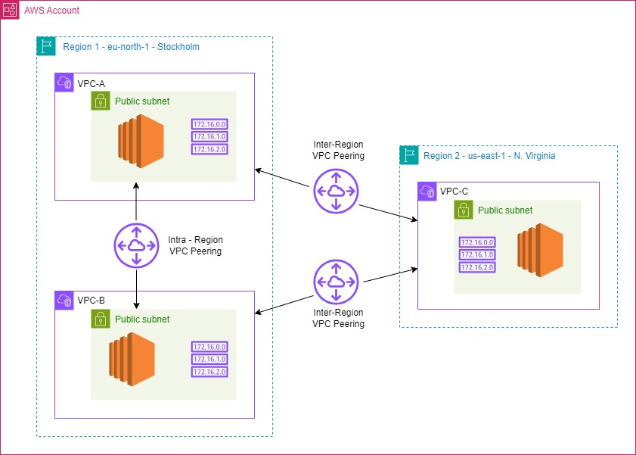
In this hands-on we have configuring an Intra-region VPC peering (b/w two AZ’s) and Inter-region VPC peering between three VPC’s.

Steps:
- Creating VPC’s

- We have to create three VPC’s as per mentioned below; two are in same region but in different AZ’s and third in another region.

1. mycloud-vpc-a – eu-north-1a (Stockholm) – 10.0.0.0/16
2. mycloud-vpc-b – eu-north-1b (Stockholm)- 11.0.0.0/16
3. mycloud-vpc-c – ap-south-1a(Mumbai)- 12.0.0.0/16

- Launch EC2 instances in each VPC’s in public subnet and configure security groups by allow ssh from internet and ICMP from anywhere IPV4.
- Configure route tables for each VPC’s accordingly.

- Configure Peering connections

- Create Intra-Region - Inter AZ VPC Peering (mycloud-vpc-a to mycloud-vpc-b)
- Go to the VPC Dashboard in Region(eu-north-1)
- Select "Peering Connections" and click "Create Peering Connection."
- Choose mycloud-vpc-a as the requester and mycloud-vpc-b as the accepter.
- Name the peering connection as peering-a-b and click "Create Peering Connection."
- Accept the peering connection from the mycloud-vpc-b side.

- Create Inter-Region VPC Peering (mycloud-vpc-a to mycloud-vpc-c):
- Go to the VPC Dashboard in Region 1(eu-north-1)
- Select "Peering Connections" and click "Create Peering Connection."
- Choose mycloud-vpc-a as the requester and mycloud-vpc-c as the accepter.
- Specify the VPC ID of in mycloud-vpc-c Region 2(ap-south-1)
- Name the peering connection as peering-a-c and click "Create Peering Connection."
- Accept the peering connection from the mycloud-vpc-c side in region 2 (ap-south-1)

- Create Inter-Region VPC Peering (mycloud-vpc-b to mycloud-vpc-c):
- Go to the VPC Dashboard in Region 1(eu-north-1)
- Select "Peering Connections" and click "Create Peering Connection."
- Choose mycloud-vpc-b as the requester and mycloud-vpc-c as the accepter.
- Specify the VPC ID of mycloud-vpc-c in region 2.
- Name the peering connection as peering-b-c and click "Create Peering Connection."
- Accept the peering connection from the side mycloud-vpc-c in region 2.

- Configure Route Tables:

- Update Route Tables for mycloud-vpc-a and mycloud-vpc-b
- Go to the Route Tables section in the VPC Dashboard.
- Select the route table associated with the public subnets of
mycloud-vpc-a
- Add routes for mycloud-vpc-b and mycloud-vpc-c with the peering connection as the target and destinations as for specific VPC CIDR ranges.
- Repeat the process for mycloud-vpc-b, adding routes for mycloud-vpc-a and mycloud-vpc-c.

- Update Route Tables for mycloud-vpc-c:
- Go to the Route Tables section in the VPC Dashboard in Region 2.
- Select the route table associated with the public subnets of mycloud-vpc-c.
- Add routes for mycloud-vpc-a and mycloud-vpc-b with the peering connections as the target.

- Check the peering connections between each VPC’s

We can ping the private IP address of EC2 in mycloud-vpc-b and mycloud-vpc-c from EC2 instance in mycloud-vpc-a.

And we can ping the private IP address of EC2 in mycloud-vpc-c from EC2 instance in mycloud-vpc-a and mycloud-vpc-b.

